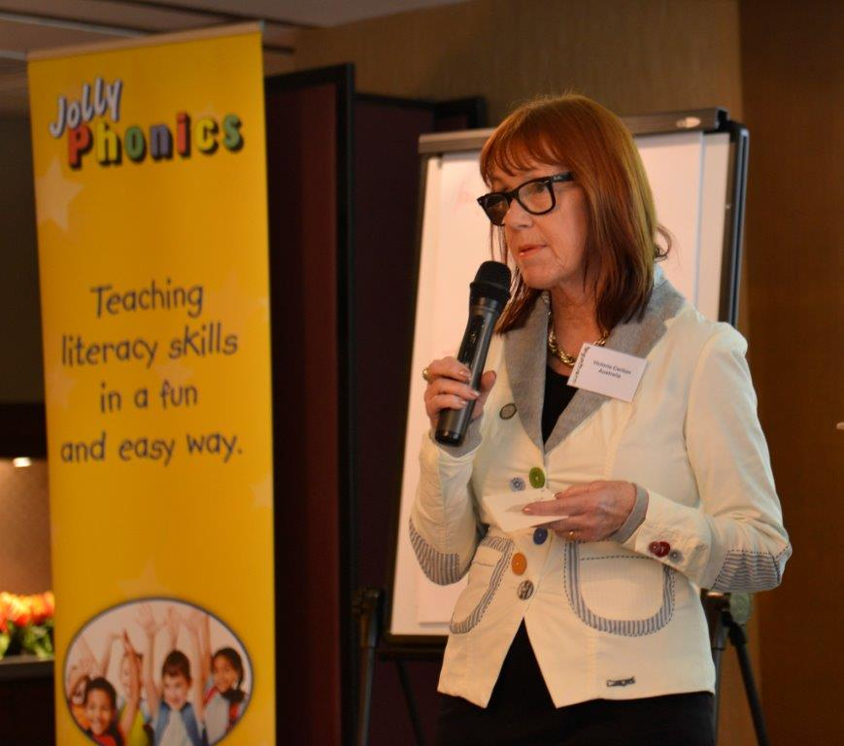
Jolly Phonics is:
- A fully researched, synthetic phonics and multi-sensory literacy program that opens the door to reading for ALL children. Jolly Phonics teaches all the main sounds by using a unique set of actions, making the learning effortless and fun!

The Jolly Phonics and Jolly Grammar programs empower ALL students to read, spell and write.

By attendance at this thought-provoking and practical seminar you will learn:
- Why this approach is so effective and multisensory methods to introduce the sounds.
- Which sounds to introduce and a suggested order.
- Practical, structured strategies to improve phonemic awareness and teach phonics and early reading skills.
- How to use the new Jolly Phonics Reading Assessment.
- Ways to timetable Jolly Phonics into your teaching program and Victoria’s unique, creative approach to this program and extra teaching strategies.
- How to use Jolly Phonics to help older children who are struggling with literacy skills.

Attending teachers will receive 19 extra helpful games/products/planning docs to help them plan practical and interesting approaches to Jolly Phonics.

Who should attend? Teachers and teaching assistants from K-Grade 3 and any staff who work with children with learning difficulties.

JOLLY PHONICS fits within the national curriculum guidelines and will promote higher literacy standards for all your students.

Date: Tuesday 2nd May 2017 Time: 9am - 3pm
Venue: Ibis Hotel 27-35 Turbot St, Brisbane 4000
Investment: $295.00 (includes GST) Lunch will be provided
Places are limited so please ring or fax your details as soon as possible. Phone: (08) 9271 4200 Fax: (08) 9271 4211
Payment MUST be made before the course date. We reserve the right to cancel any seminar which does not receive the minimum number of bookings. JP Bne02May17
Attendee Name: _______________________ Attendee Email: ___________________________
Attendee Mobile: ______________________ School: __________________________________
Any special dietary requirements?

Payment form: EFT, cheque or credit card (please circle). Please make cheques payable to the International Centre for Excellence and post to ICE, 19 King William Street, Bayswater WA 6053
Credit Card Number: _______ _______ _______ _______ Expiry Date: __/__
Name on Credit Card: _____________________________ Amount: ________
Signature: ______________________

