Many children HATE writing and will do ANYTHING to avoid it-including making your classroom a battlefield!

Discover WHY reluctant writers hate writing and WHAT YOU CAN DO ABOUT IT!

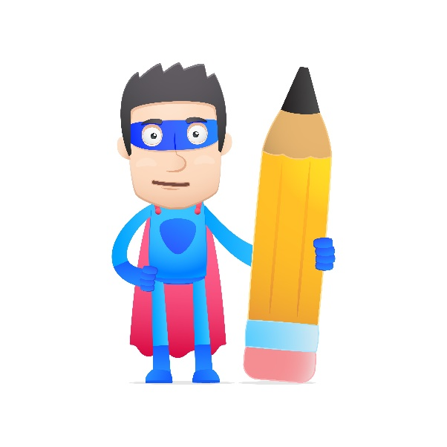
EMPOWER YOUR CHILDREN TO BECOME COMPETENT. CONFIDENT WRITERS WHO ENJOY THE PROCESS.

- Discover CREATIVE, CHILD- FRIENDLY and ENJOYABLE ways to empower your young writers.
- Learn how to use “right-brain” methods to stimulate and revitalise writing. Try out our unique MIND JOURNEYS approach!

- Apply knowledge about the 8 intelligences to the writing process.

- Learn how to teach students the 7 steps to effective writing.

This workshop will leave you energised, revitalised and enthusiastic to begin a new approach to writing! We have trialled these strategies for more than 10 years and know they work!

Attending teachers will receive a copy of Victoria’s new book: MIND JOURNEYS, list of suitable literature to provide models for writing, a set of writing affirmations, a set of writing starters and 20 writing and associated vocabulary motivation cards.
Who should attend? This workshop is suitable for educators of students aged 6-13
Venue: 19 King William St. Bayswater Date: Monday 26th June 2017 9:00am to 3:00pm Investment: $280 (includes GST) Full notes, Lunch and Morning tea provided.

Places are limited for this seminar so please ring or fax your details to ICE as soon as possible.
Phone: 9271 4200 Fax: 9271 4211
We reserve the right to cancel any seminar which does not receive the minimum number of bookings.
Name: ___________________ Mobile No: __________________________ DATE: AKCW PER 26June17
School: ___________________________ Special dietary requirements?______________
Payment form: EFT, cheque or credit card (please circle).
Please make cheques payable to the International Centre for Excellence and post to
ICE, 19 King William Street, WA Bayswater 6053
Credit Card Number: _______ _______ _______ _______ Expiry Date: __/__
Name: ______________________Amount: _________
Signature: ______________________ Payment must be made before workshop.

