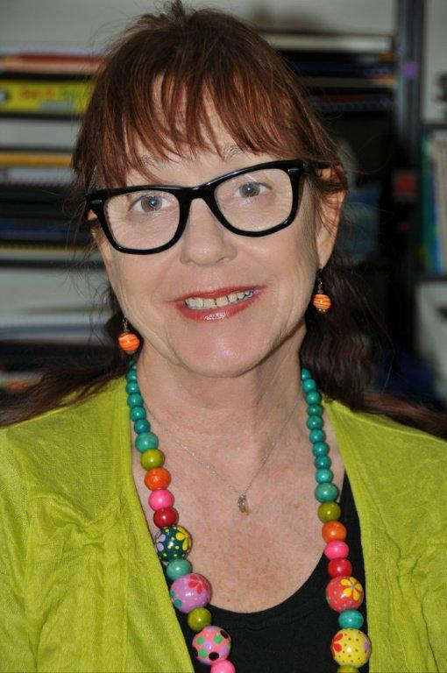
ATTENTION ALL PARENTS.

ARE YOU CONCERNED ABOUT YOUR CHILD’S ACADEMIC PROGRESS?

We CAN help. We provide a comprehensive educational assessment coupled with an analysis of your child’s preferred learning style and comprehensive learning plan. This holistic approach empowers you to provide the best possible educational programs to help your child “reach for the stars”.

The full educational assessment is administered by Victoria Carlton, the Director of THE INTERNATIONAL CENTRE FOR EXCELLENCE. (Australia www.ice-au.com ) Victoria has over 30 years experience working with children with learning difficulties, dyslexia, gifted children and children with attentional disorders.

Victoria is known internationally as the “Child-Whisperer” due to her uncanny ability to bond and connect with children of all ages. She is able to see beyond the barriers and disguises they erect to help construct learning pathways that lead to success. Children love to spend time with Victoria!

This form of assessment is suitable for all children so that parents can ensure their children’s educational needs are being met.

The assessment will give you this information-
- Reading stage reached and level of comprehension skills, ability to decode new words and phonological knowledge. Children’s reading will be analysed to determine if they have knowledge of story grammar and an awareness of literature features.

- Readiness for formal learning stage is assessed if necessary. This determines whether a young child is ready to commence a formal literacy and numeracy programme and if any steps need to be carried out to prepare the child for this important step.
- Spelling stage reached, and information about the strategies a child is using to help them to spell conventionally. Any difficulties are noted and types of spelling errors are noted so that an appropriate teaching programme may be drawn up.

- Strengths and weaknesses in the 8 major intelligences so you can plan appropriate education pathways.

- Oral language skills will be observed and analysed to discover whether a child is able to think logically and clearly and express their ideas in a coherent, appropriate manner.

- Visual and auditory memory skills will be examined to determine strengths and deficits.

- Sequencing ability will be examined as this skill relates to so many academic areas.

- Written expression tests will be carried out to show us the level of understanding your child has reached in this area. Children will also be tested to determine their knowledge of the frameworks of simple narrative and non- narrative genres

Eye muscle movements will be noted in case your child needs to consult a behavioural optometrist. Gross and fine motor skills are analysed to determine if they are age appropriate or whether further development needs to take place. Fluency of Midline movements and balance skills will also be noted for possible difficulties.

- Mathematical skills will be examined to determine understanding of basic mathematics concepts, mental computational skills and ability to problem solve.

Testing takes approximately 1.5 hours, including a review with
the parents at the end of the session about the results of the
testing.

Within 3 weeks you will receive a written report that
summarises all our findings and gives recommendations for
improved academic development.

Out testing differs from many other forms in that it is diagnostic as well as practical in that it points the way to an effective learning programme for each child tested. The testing involves formal as well as informal testing instruments.

